Online Form Automation Execution Guide

Step 1: Extract the ZIP File
Download the project ZIP file (form_automation)
- Extract the contents of zip file into any directory of your choice
  - Selecting the download file
  - Right click on the selected downloaded zip file
  - Click on Extract All option from the pop-up menu
E.g. In below screenshot it is extracted at downloaded and Downloads folder.
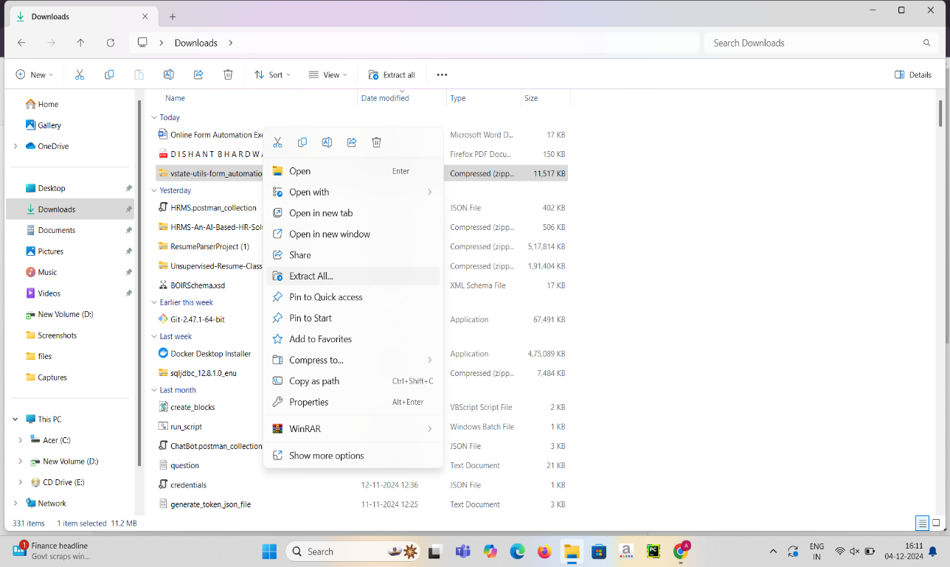
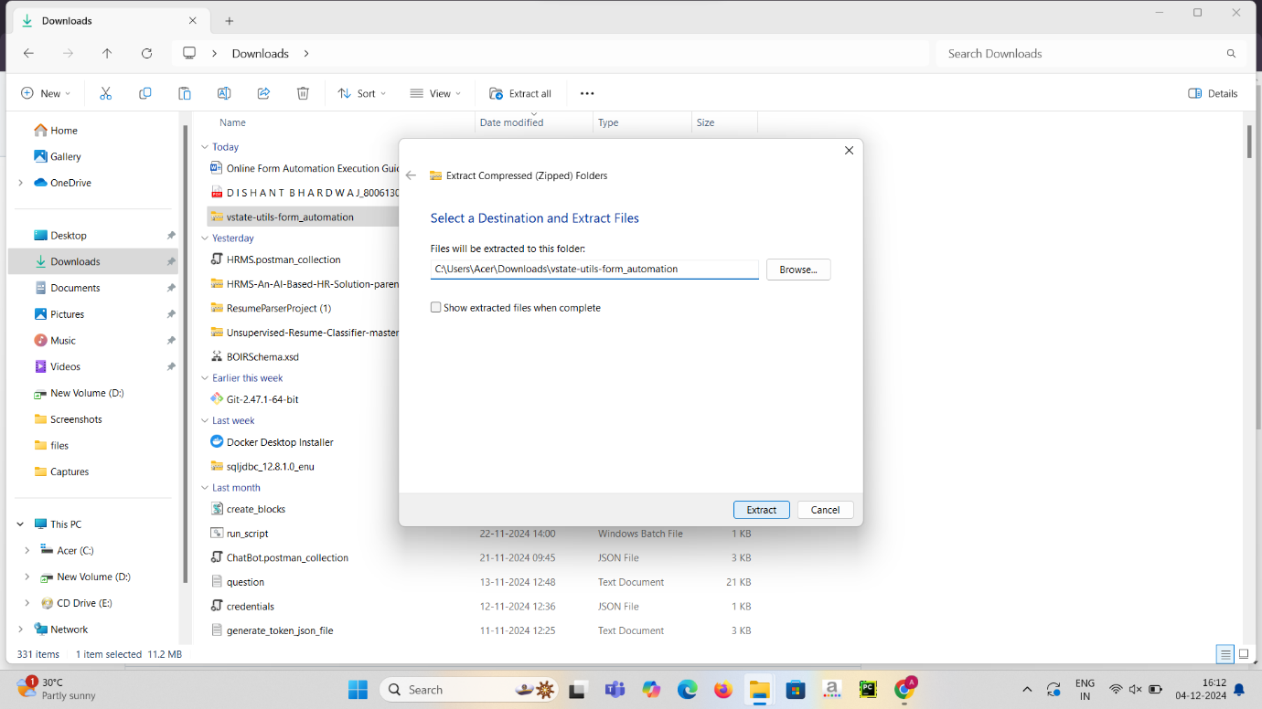

Step 2: Configure the Project
- Once extracted, go inside the extracted folder. You will find config.txt file.
- Open the config.txt file located in the project folder.
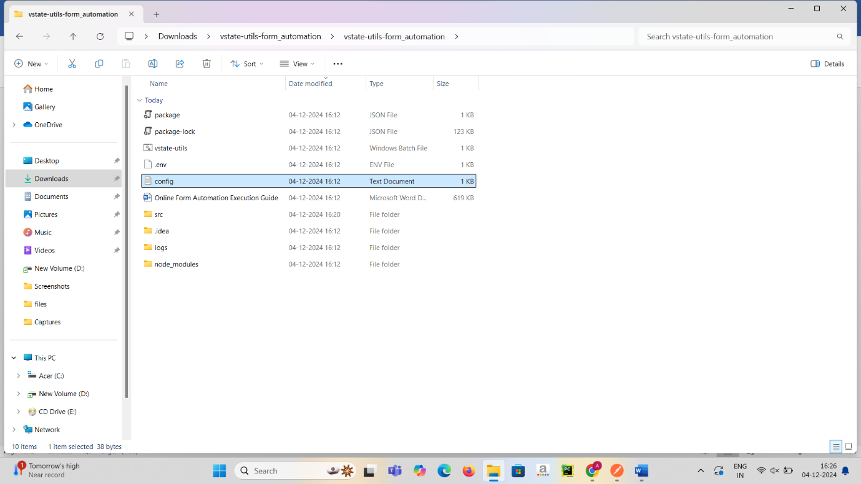
- Replace the existing path with our absolute path of the project directory as mentioned in the screen shot below as an example.
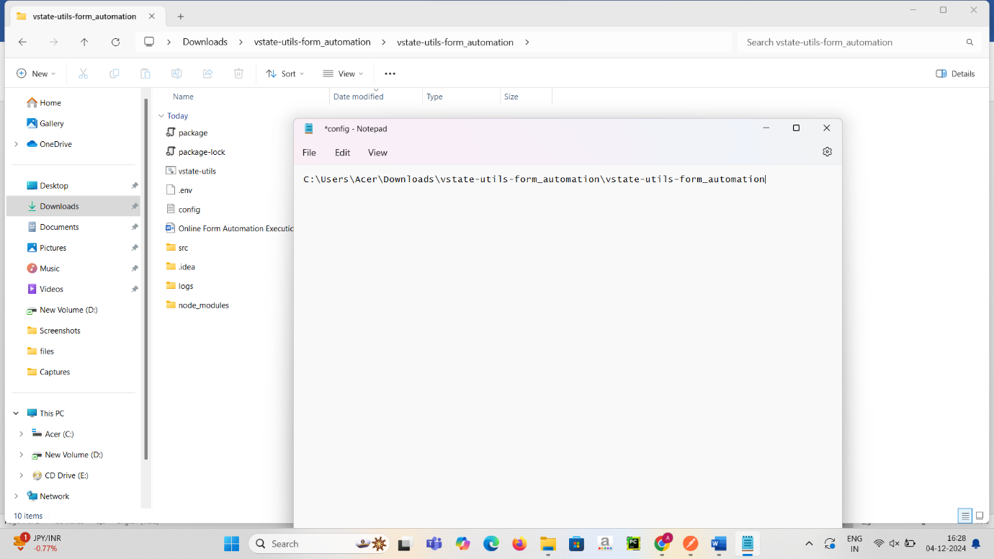
- Save this txt file with press ctrl + s
- 

Step 3: Create a Shortcut for the Batch File
- Right-click on the vstate-utils.bat batch file and select Show more options.
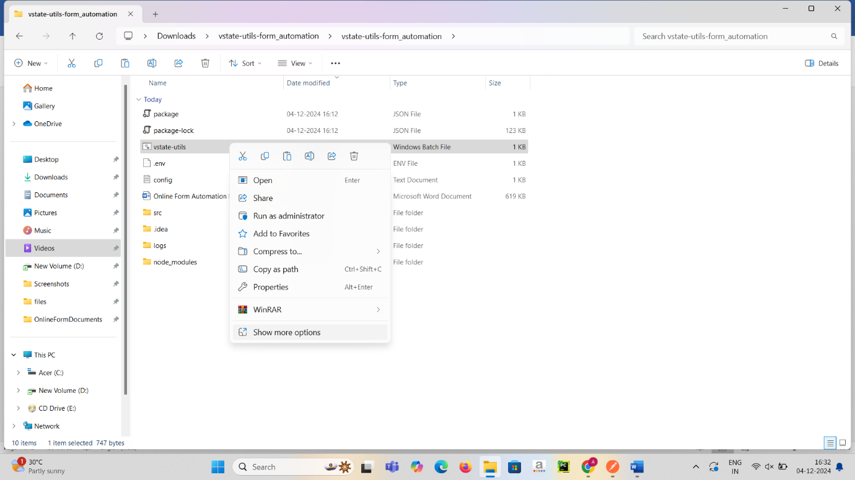
- Then Select Create shortcut. This will create a shortcut file at the same location. 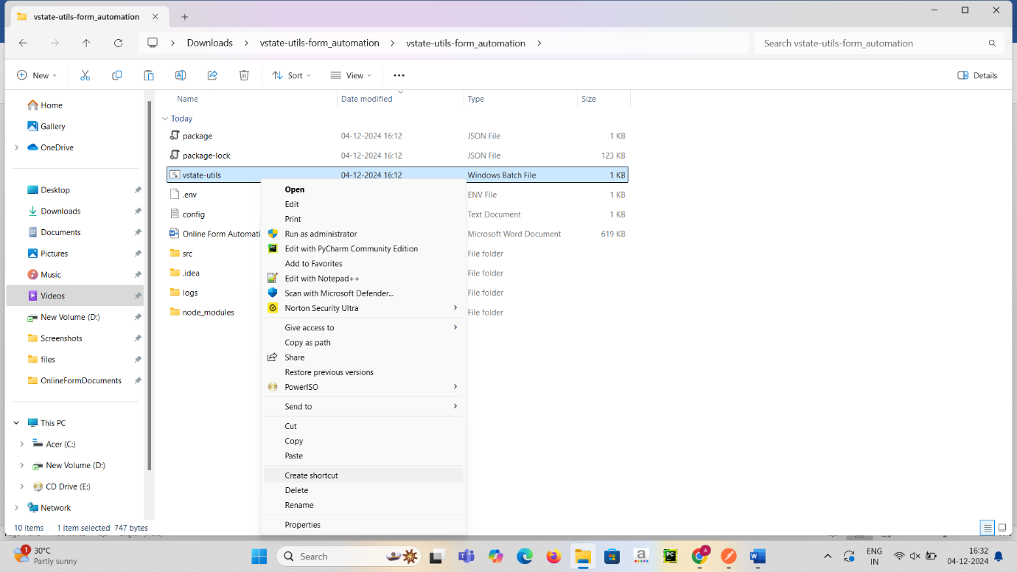

Step 4: Add the Shortcut to Startup
- Press Win + R to open the Run dialog box. (this will open a small window in corner)


- Type shell:startup in Run menu of Windows and press Enter. This will open the Windows Startup folder.
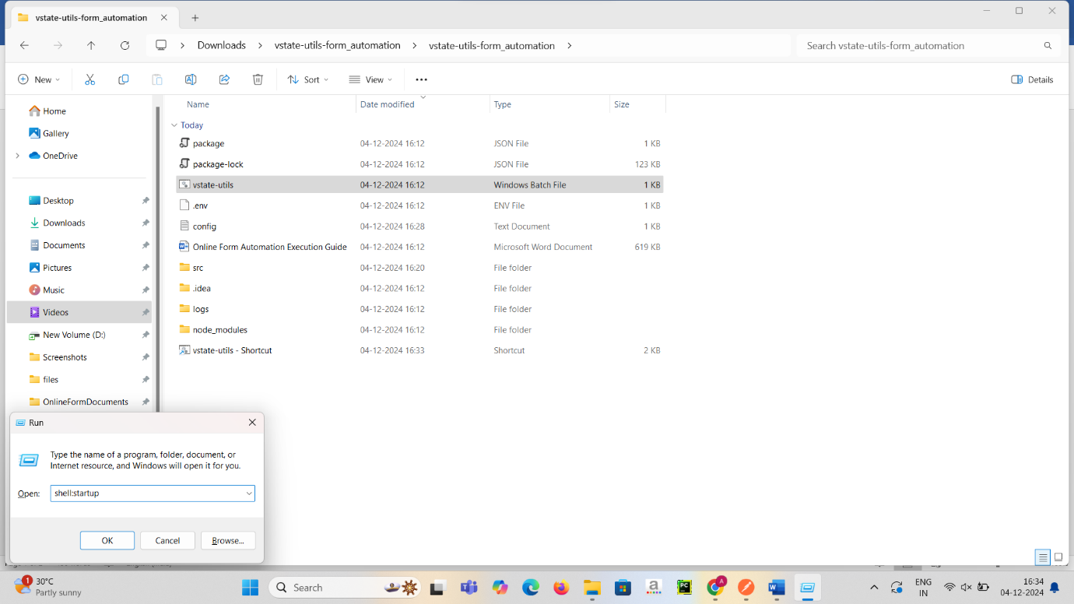
- Copy the created shortcut file which we created before in project folder.
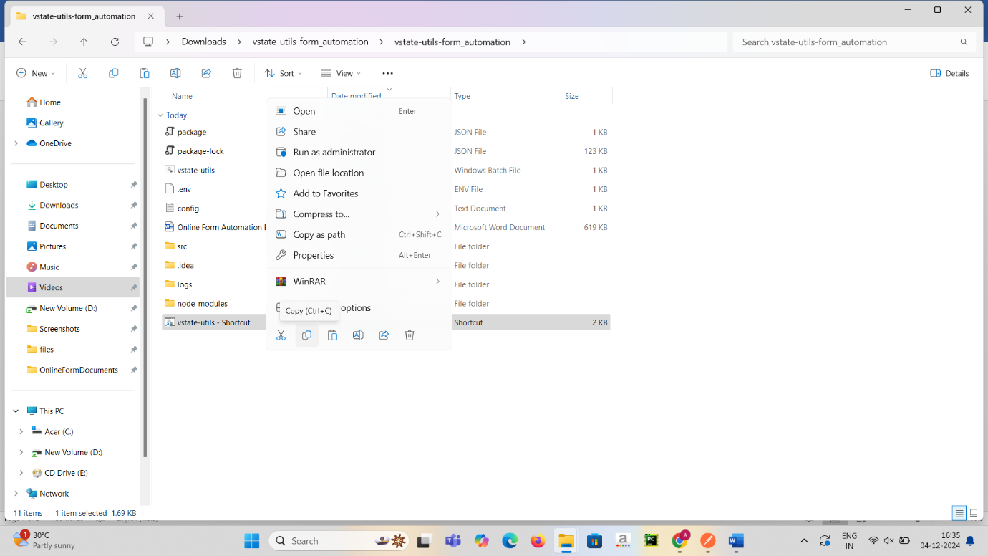

- And paste into the Windows Startup folder.
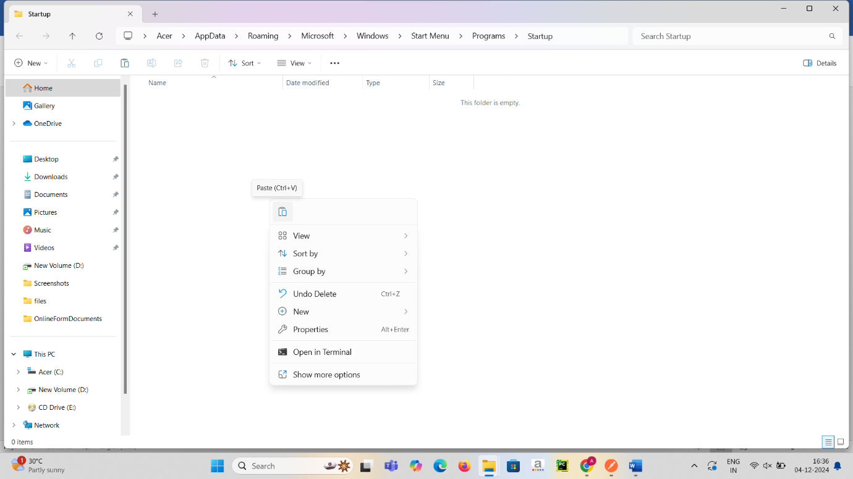
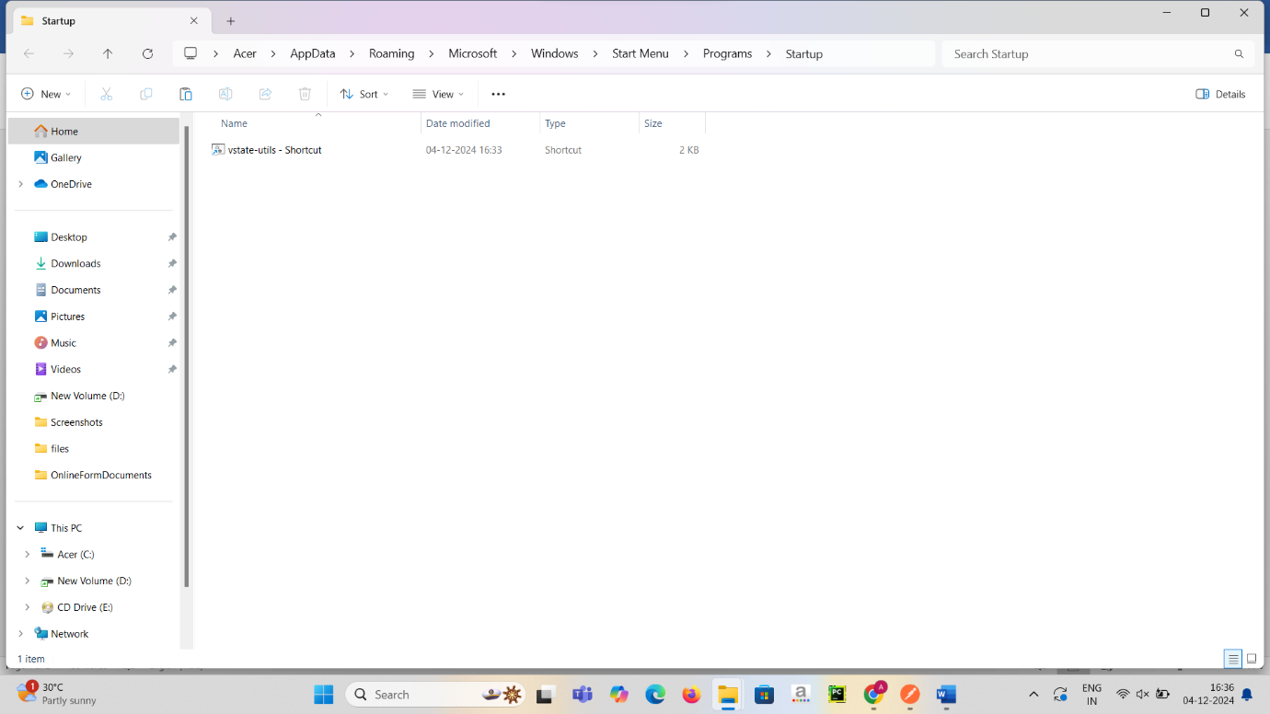

Step 5: Verify the Setup
- Restart your system to ensure the batch file runs automatically at startup.

